Worthy Brother Knights,

This is Brother Nicholas Bezzina, Field Agent with the Knights of Columbus Southern California Agency and current Faith Director for Council 6020 in Huntington Beach California under the leadership of our Worthy Grand Knight and Perpetual Adoration Chairman for the Knights of Columbus in California, Steve Levison.

The nipht Steve and I meet I got off work about four hours later then I planned. If memory serves this was in 2017. At the time I was not a Field Agent nor a Knight being 23 years old; nor did ever becoming a Knight or Field Agent entered my mind. After getting off my shift at my current job later than expected I went to pray before Our Lord in my local Adoration Chapel. Since this day was really ruff, I prayed before Our Lord: "Lord, give me something to do for you. Give me work that is connected to the Church. Give me work for you. Let me do what you want me to do."

Just then the door to the Chapel opened. Steve walked in. After he spent time in prayer, I was approached by him right there in the Adoration Chapel. "Excuse me," he said, "I want to know if you want to join me in championing Eucharistic Adoration in our Diocese under the leadership of Bishop Kevin Vann." Steve then proceeded to tell me he was just ending a pilgrimage to San Francisco in support of 24/7 Eucharistic Adoration. Steve had recently been given authority by Bishop Vann to grow Eucharistic Adoration in the Diocese of Orange. Stopping at Churches and Missions up and down California's coast Steve prayed to God to give him a "young person" to join the Diocesan Adoration team. Getting home later than expected due to a wrong turn, which added additional hours to his originally planned trip, Steve ended his pilgrimage where he started it, at this very Adoration Room that I was in. I remember looking up at Steve and telling him I didn't plan to be in the chapel at this moment either. Both of us knew this was providential. I then joined Steve in solidarity with our Bishop to promote Eucharistic Adoration in our Diocese right there and then before our Lord in the Tabernacle.

One of the first things Steve told me was he was a proud member of the Knight of Columbus and how Supreme Knight Carol Anderson has called the Knights of Columbus, "Knights of the Eucharist." Steve joined the Knights in 2007 because he read Carl Anderson's writings stating that the Knights of Columbus were also the Knights of the Eucharist as well as the Spiritual Right Arm of the Church. He told me Bishop Vann has asked all Knights in the Diocese to be the ones to champion Eucharistic Adoration. I then proceeded to take the First Degree ceremony on May 15th, 2017, Second Degree on the Feast of the Exaltation ff the Holy Cross, September 14th, 2017, Third Degree October 14th, 2017, and eventually the Fourth Degree in 2020, leading me to be the 3rd generation of 4th Degree Knights in my family.

Needless to say, the Knights of Columbus are a huge part of my life, and I can't imagine myself having a career anywhere else. I am blessed to be working at an organization where I can practice the Catholic Faith while also serving my Brothers and their families. At our Monthly Agency meeting I am the Agent who usually leads the opening prayer invoking Blessed Father McGivney, Saint Joseph, and Our Blessed Mother for our Brother Knights and all the people we know, love, and serve. I cannot help but to see God's providence in all of this. Looking back on it I believe my career as a Field Agent was born in that Adoration Chapel as well as the work Our Lord wants of me, which He truly wants of all the Knights of Columbus, the call to be Knights of the Eucharist.

I can see my story reflected in the words of Patrick Kelly on the day he became our Supreme Knight: "On the day I was installed, I spoke of our calling to be Knights of the Eucharist," Supreme Knight Kelly said. "The more we devote ourselves to the Eucharist, the more we will understand what it means to be a Knight - to live a life of service and sacrifice for others and to live a life of true unity, centered on the 'source and summit' of the Christian life."1

It is providential that at the same time Steve become our Grand Knight, the Bishops announced the next three-years in our Church will be focused on Eucharistic Revival. With this call from the Bishops, we Knights of Columbus should feel a strong conviction to fulfill what they asking of us and champion this Spiritual and Eucharistic Revival by the promotion of the Personal Holiness of the Members! Our Supreme Knight has already said we would! "In his annual report at the 139th Supreme Convention in August 2021, Supreme Knight Patrick Kelly announced that the Knights of Columbus would be a major sponsor of the, [Eucharistic] revival. He also called on members of the Order to be ready to assist their bishops and pastors as true "Knights of the Eucharist" ."2 Now is the time for each and every Knight to start participating in Eucharistic Adoration, and for Knights far and wide to start organizing Eucharistic Processions.

Archbishop Lori, our Supreme Chaplin, is also calling for the KofC to, per the will of the Bishops, promote devotion to the Blessed Sacrament. Catholic New Agency has made it known that the Knights of Columbus will be the main organizers of this Eucharistic Revival by quoting our Supreme Knight Patrick Kelly in saying "The example of St. Joseph teaches us how to be Knights of the Eucharist. He was the guardian of the first tabernacle - beginning with Mary herself when she bore Christ in her womb, and then in the home where he and Mary lived with Jesus," ..."As Knights, we too are called to have a special reverence for Christ's real presence," he said. "The more we dedicate ourselves to Christ in the Eucharist, the more we will be a sign of unity in an age of division and disbelief." Earlier in the day, Archbishop Lori called on the Knights to lead the way on the bishops' proposed Eucharistic Revival project, promoting devotion to the Eucharist in their communities." 3

Now, as a young man of 28 years old, as a Field Agent for the Knights I can honestly say that I have seen a lot of Councils inside and out, as well as seeing the NEEDS the Knights are currently facing. Not every Catholic man will be drawn to the Knights of Columbus like I miraculously was. We need to recognize as a Brotherhood there is the lack of young adult men joining Knights membership and that

there is also a lack of focus on spirituality in the Councils of our Order. It pains me to say this, but I say this out of charity, and to call for a spiritual renewal among our membership. The reason young men are not joining is because they do not have an interest to merely fundraise money, although noble, they are also looking for something more: serious authentic Catholic Spirituality. The answer to this is the Eucharist. Young Catholic fathers need to be exposed to the Knights Spiritual resources. More young members of our Church will recognize the KofC as a Spiritual powerhouse if Council focus more on authentic Catholic Spiritually. If we do not step it up NOW and live the message of "Into the Breach," there will be no more future generation of Knights to take up the banner of the Order and fulfill the vision of Blessed Father McGivney. This also feels like a mission of mine, and I recognize this mission cannot succeed without our Lord. Just as I was recruited into the Knights in front of The Blessed Sacrament, so will other young men as well. What did Father McGivney found our Order for, if not to assist Catholic families and the whole world with their physical and, more importantly, spiritual needs by preaching and living the Gospel message? "In this light, the Eucharist shows itself as the source and the apex of the whole work of preaching the Gospel."4 If the Knights truly excel at being Knights of the Eucharist by the promotion of Eucharistic Processions and Adoration, more young adults will be draw to the KofC to be a part of this spiritual Brotherhood that is bringing Jesus to a wounded world. Making Eucharistic Adoration a fundamental and critical part of our Brotherhood is critical in the years to come. Young men are interested in joining an organization that is truly spiritual to its core. Knights taking the lead in growing Eucharistic Adoration and organization of Eucharistic Processions will give the Knights membership increases. More young members of our Church will recognize the KofC as a Spiritual powerhouse because we put our Lord first!

The Fruits of what I have suggested above have already been reaped by Council's who have promoted Holy Hours at their Parishes and listened to the call from·our Superiors. One example is from a KofC article that states "This has been a great opportunity for men to come in and spend time with our

Lord," Coleman said, noting that the Knights' witness in promoting Holy Hours and devotion to the Eucharist has helped inspire more men join the Order. "With the Holy Hour," he said, "we've been able to attract faithful men who believe in the real presence of Christ in the Eucharist and who look forward to serving with other faithful men."5

Father McGivney's life as Parish Priest was centered around the Eucharist. He Baptized children to lead them eventually to the Eucharist, he absolved sins in the confessional to bring sinners back to the Eucharist, and he celebrated Mass devoutly and frequently to give his flock the Eucharist. The Communion Antiphon for the Votive Mass of Blessed Michael McGivney quotes a beautiful Scripture passage: "Blessed is the servant whom the Lord finds watching when he comes. Amen, I say to you: He will put him in charge of all his property." Cf. Mt 24: 46-47."6 Will you as a Knight be that Faithful

Servant whom He finds watching? Will we follow in the footsteps of our Founder and have our lives truly revolve around the Eucharist? Our Lord has stated clearly "Abide in me, and I in you. As the branch cannot bear fruit of itself, unless it abide in the vine, so neither can you, unless you abide in me. I am the vine: you the branches: he that abideth in me, and I in him, the same beareth much fruit: for without me you can do nothing. If any one abide not in me, he shall be cast forth as a branch, and shall wither, and they shall gather him up, and cast him into the fire, and he burneth." (John 15: 4-6) As Knights of Columbus, are we committed to abide in Him, to stay close to Him, to bring Him to the world!? Are we going to answer this call my Brothers? Are we instead going to leave our Lord? Lord, to whom shall we go? (John 6:69)

St. John Paul II put it the best when speaking directly to Knights of Columbus: "As "the vital and enduring center around which the entire community of the Church is gathered" (Ecclesia in America, 35), the Eucharist is at once the source of every apostolate and the Church's greatest spiritual treasure. May a deep and abiding devotion to Jesus Christ, present in the Most Holy Sacrament of the Altar, mark the spiritual life of every Council, inspire an ever more vigorous apostolate of service to Church and

community, and bring about that transformation of society in accordance with God's will which is the essence of the lay vocation I take this opportunity to echo the gratitude expressed by so many

Bishops and priests for the spiritual and personal support given to them by the Knights of Columbus in their local and state Councils. As the Church in America seeks to move forward with sincere faith and confidence in the Lord's sustaining grace, I urge all the Knights and their families to intensify their prayers for the authentic renewal of ecclesial life and the preservation of "that unity which has the Spirit as its origin an..d peace as its binding force" (Eph 4:3)." 7

I want all Catholic men to be enrich by the Eucharist through the Knights of Columbus. If the

Knights truly excel at being Knights of the Eucharist by the promotion of Eucharistic Processions and Adoration, more young adults will be draw to the Knights of Columbus to be a part of this spiritual Brotherhood like I was. This is what our Superiors are asking of us. Our Lord has blessed us with the Knights through Father McGivney, its time the Knights bring more Catholic men to our Lord before the tabernacle to bless Him.

Vivat Jesus et Maria,

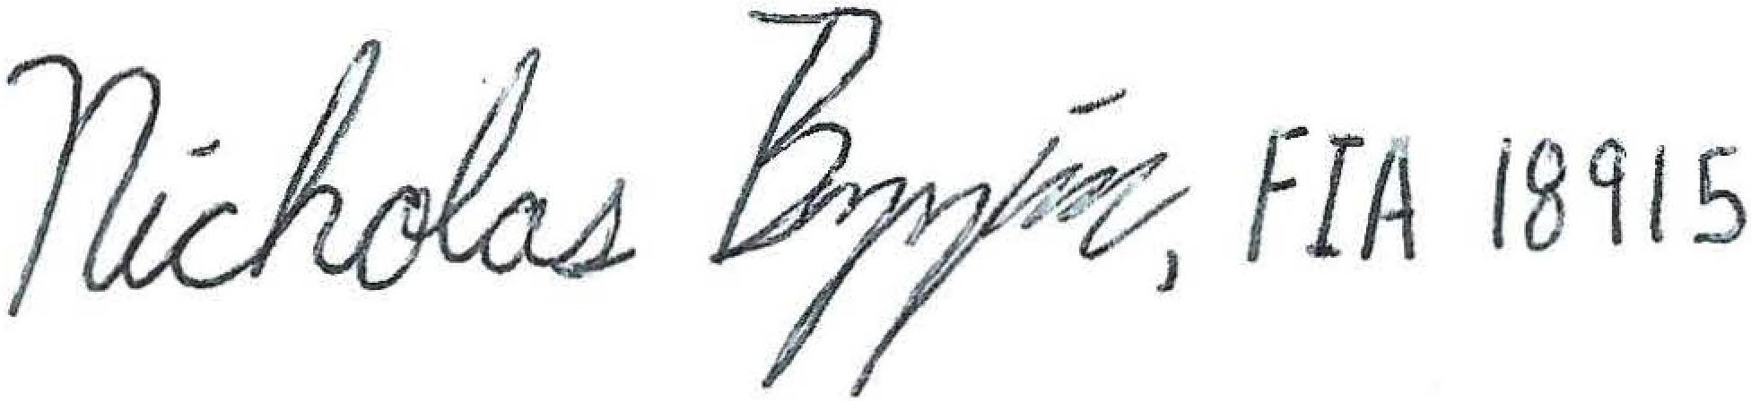

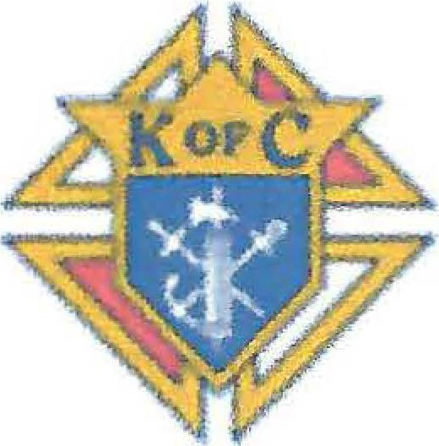Nicholas Bezzina, FIA 18915 Knights of Columbus Insurance Southern California Agency

**Knights of**

**Columbus·**

[Signed in the presence of the Blessed Sacrament and the burial place of Blessed Father McGivney at Saint Mary's Catholic Church, New Haven, Connecticut October 22nd 2022 - Feast of Saint John Paul 11.]

# Sources:

1. [https://www.kofc.org/en/news-room/columbia/2022/june/knights-of-the-eucharist.html](http://www.kofc.org/en/news-room/columbia/2022/june/knights-of-the-eucharist.html)

# https:/[/www.kofc.org/en/news-room/columbia/2022/june/source-and-summit.html](http://www.kofc.org/en/news-room/columbia/2022/june/source-and-summit.html)

1. [https://www.catholicnewsagency.com/amp/news/247979/new-supreme-knight-urges-members-to­](http://www.catholicnewsagency.com/amp/news/247979/new-supreme-knight-urges-members-to) be-knights-of-the-eucharist

# Second Vatican Council, Presbyterorum Ordinis, section 5.

[https://www.vatican.va/archive/hist_ councils/ii_](http://www.vatican.va/archive/hist_councils/ii_vatican_council/documents/vat)vatican[_council/documents/vat­](http://www.vatican.va/archive/hist_councils/ii_vatican_council/documents/vat) ii_decree_19651207_presbyterorum-ordinis_en.html

1. [https://www.kofc.org/](http://www.kofc.org/en/news-room/columbia/2022/june/knights-of-the-eucharist.htmI)en/[news-room/](http://www.kofc.org/en/news-room/columbia/2022/june/knights-of-the-eucharist.htmI)colum[bia/2022/june/knights-of-the-eucharist.htmI](http://www.kofc.org/en/news-room/columbia/2022/june/knights-of-the-eucharist.htmI)

# Communion Antiphon of the Votive Mass of Blessed Michael McGivney

https:/[/www.kofc.org/en/resources/events/father-mcgivney-beatification/votive-mass-blessed­](http://www.kofc.org/en/resources/events/father-mcgivney-beatification/votive-mass-blessed) mcgivne-booklet.pdf

1. [https://www.kofc.org/un/en/resources/communications/Papa1Ms_2002.pdf](http://www.kofc.org/un/en/resources/communications/Papa1Ms_2002.pdf)